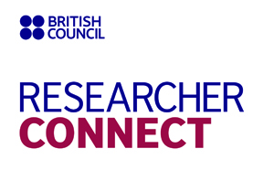
Professional development workshop

Kyiv 11-13 October 2017
Kyiv 18-20 October 2017
(pl. tick the one you are applying for)

Application form
Full name

Date of birth

Place of work

Job position

Field of research

International research experience

Contact information (mobile number, email address, Skype name if available)

Level of English language competence

Please explain what are your priority needs for development as a researcher (up to 100 words)

Date of application

Signature

Please complete the application form and send it to the British Council on the email address: UA_IHE@britishcouncil.org.ua. NB: In the subject line of your email please indicate “Researcher Connect Workshop”. Deadline for submitting applications is 5 October 2017.
Contact point for enquiries: Maria Zakharova, Education Projects Co-ordinator, Tel.: (044) 490 5600.

